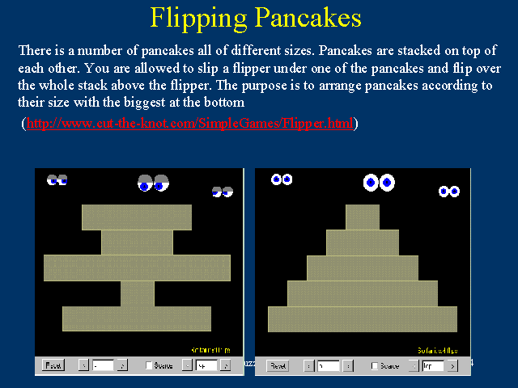

The idea here is you design an algorithm that flips the pancakes so that the stack looks like the right picture. There can be any starting position you do not want to solve it randomly. Try and program the solution. It would be good if your program showed the stack of pancakes at each step as part of the output.

The following output would represent the stack on the left.

\*\*\*\*  
\*\*\*  
\*\*\*\*\*\*  
\*\*  
\*\*\*\*\*

AND then show the stack after each flip.